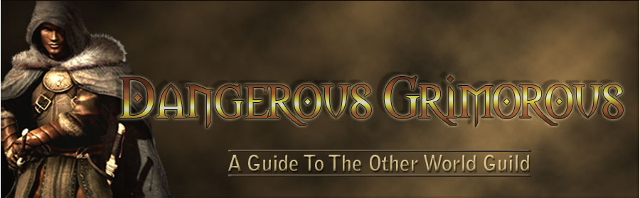

Dangerous Grimorous Other World Guild
Welcome to The Other World Guild of Dangerous Grimorous. We are so glad you've entered the realm of this useful guide to Dangerous Grimorous.
Many Guild members share their knowledge in the companions section of this adventure-filled world. That's over many years and over many online lives. Thanks guys and gals.
Check out all the links to our scripts and updates. There are lots and lots of goodies to help you in your quests.
On behalf of all the Guild Members, we wish you the best of luck in our online realm. May this site help and guide you to an extremely successful life in our Other World.
May the winds be always to your advantage.

DG News
Righteous Wrath Updates
DG Verb Update
Bards Meeting
Staff Specials
DG Realm Makeover
Play Dangerous Grimorous

All rights reserved. © Dangerous Grimorous 2005-201?
Legals
Site By Ambi Design

